TASK 4: DATA STORYTELLING & STATISTICAL VALIDATION
Student Details
Name: Konda Vaishnavi
Internship Task: Task 4 – Data Storytelling & Statistical Validation
1. Introduction
Data analytics helps organizations make informed decisions by transforming raw data into meaningful insights. This project focuses on analyzing a fruit classification dataset to identify patterns, generate business insights, and validate findings using statistical techniques.
The objective of this task is to apply data storytelling methods and hypothesis testing to communicate insights effectively.
2. Dataset Overview
The dataset contains information about fruits and their characteristics. The key attributes used in this analysis include:
- Weight
- Colour
- Label (Apple/Banana)
- Fruit Size
- Label Code
The dataset was cleaned and preprocessed before analysis to ensure data quality and accuracy.
3. Key Performance Indicators (KPIs)
The following KPIs were calculated:
- Total Number of Fruits
- Number of Apples
- Number of Bananas
- Average Fruit Weight
- Maximum Fruit Weight
- Minimum Fruit Weight
These metrics provide an overview of the dataset and help understand fruit distribution and characteristics.
4. Data Visualization
Several visualizations were created to support data analysis:
4.1 Fruit Distribution (Pie Chart)
The pie chart shows the proportion of Apples and Bananas in the dataset. This visualization helps understand category distribution.
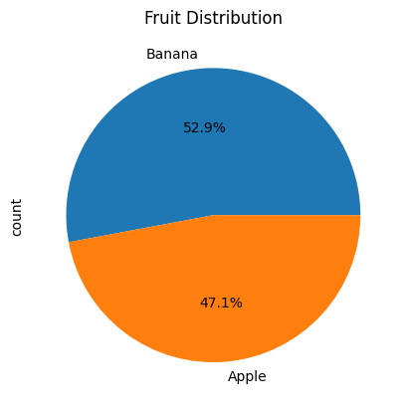
4.2 Weight Distribution (Histogram)
The histogram illustrates how fruit weights are distributed across the dataset and helps identify patterns or variations.
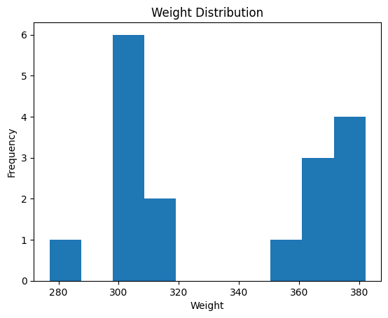
4.3 Average Weight by Fruit Type (Bar Chart)
This chart compares the average weight of Apples and Bananas and highlights differences between fruit categories.
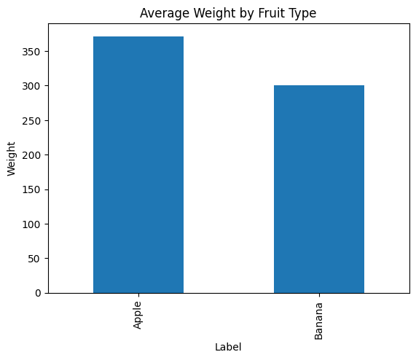

4.4 Fruit Size Distribution (Optional)
A bar chart was created to visualize the frequency of different fruit size categories.

5. Data Storytelling
The analysis revealed several important insights:
- Apples and Bananas represent the two major fruit categories in the dataset.
- Weight plays an important role in distinguishing fruit types.
- Visualization techniques simplify interpretation and improve decision-making.
- Patterns observed in the dataset can support classification and business analysis.
6. Statistical Validation
Hypothesis Testing
A two-sample T-Test was performed to determine whether there is a significant difference between the average weights of Apples and Bananas.
Null Hypothesis (H₀)
There is no significant difference between the average weights of Apples and Bananas.
Alternative Hypothesis (H₁)
There is a significant difference between the average weights of Apples and Bananas.
Test Method
Two-sample Independent T-Test
Interpretation
- If p-value < 0.05, reject the null hypothesis.
- If p-value > 0.05, fail to reject the null hypothesis.
The test result provides statistical evidence regarding the impact of fruit type on average fruit weight.
7. Business Insights
Based on the analysis:
- Fruit weight is a useful attribute for classification.
- Visual dashboards improve data interpretation.
- Statistical testing increases confidence in analytical findings.
- Data-driven approaches support better decision-making processes.
8. Conclusion
This project successfully applied data storytelling and statistical validation techniques to analyze a fruit classification dataset. The visualizations provided clear insights into fruit characteristics, while hypothesis testing helped validate observations using statistical evidence.
The project demonstrates the importance of combining data analysis, visualization, and statistical methods to generate meaningful business insights.

